The test tubes

Biology-Chemistry

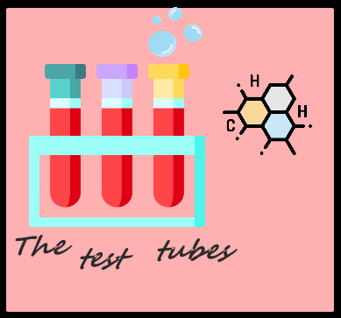

MADE BY

The test tubes

REPOSITORY

The-test-tubes

Table of contents:

1.Project idea and work on the project 2

2.Team members 2

3.Stages of the project 2

4.Difficulties encountered 2

5.Means used 2

6.Conclusion 2

# Project idea and work on the project

Ecology game which contains three difficulty levels (easy, medium and hard). The game is based on naming the best solutions to environmental problems and according to how good the answer is, different numbers of points are given. The points you score determine your success in the game.

1. Getting a basic idea of the project:

We got together in a meeting and discussed ideas and in the end we all settled on one opinion.

1. Early and late stages of the project:

We made a schedule, we worked together, everyone helped with everything. The last few days have been hard at work.

1. Presentation of the project:

We were adding the final edits to our project and all that was left was to present it.

# Team members

|  |  |
| --- | --- |
| № | Roles in the team |
| 1. | Radomir Aleksandrov – Scrum Trainer – RAAleksandrov21@codingburgas.bg |
| 2. | Stanimir Popov – Designer - SSPopov21@codingburgas.bg |
| 3. | Enis Mustafa - Back-end Developer - EEMustafa21@codingburgas.bg |
| 4. | Stilian Georgiev - Front-end Developer - SZGeorgiev21@codingburgas.bg |

# Stages of the project

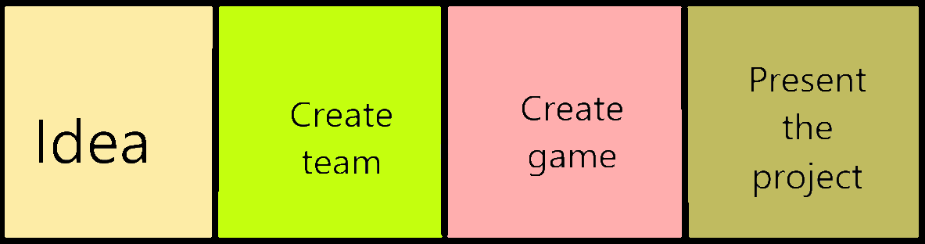

# Difficulties encountered

|  |  |
| --- | --- |
| **Making of the team** | **9/10** |
| **Making the code** | **9/10** |
| **Distributing the roles** | **10/10** |
| **Communication** | **10/10** |

# Means used

|  |  |
| --- | --- |
| Word | Tool for making the documentation |
| Power Point | Tool for making the presentation |
| Teams | Communication tool |
| Paint | Making the team logo |
| Excel | Tool for making the QA table |
| Visual studio | Tool for writing the code |
| GitHub |  |

# Conclusion

We learned a lot of new things. We improved our teamwork. We had fun and worked hard on this project activity.

# Block diagram

